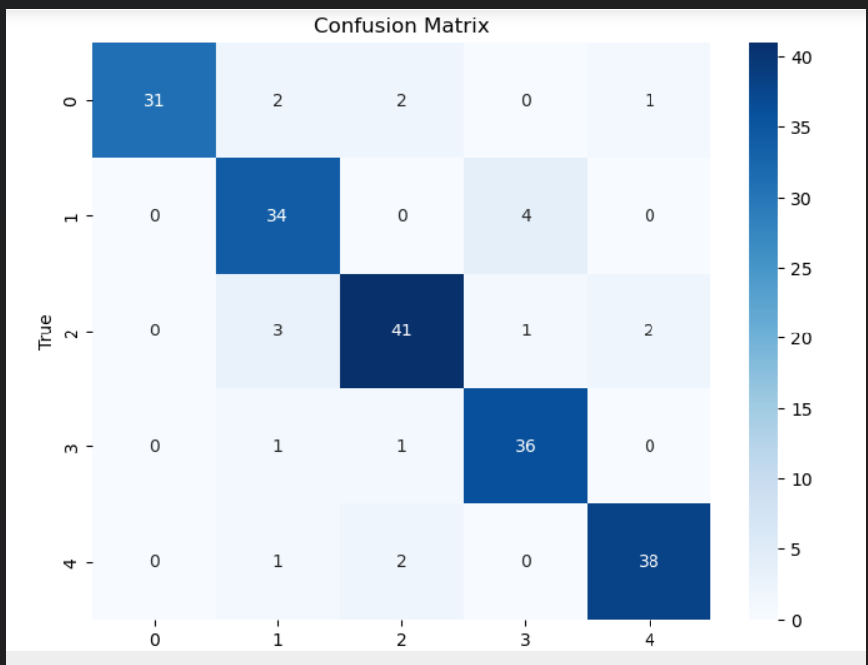

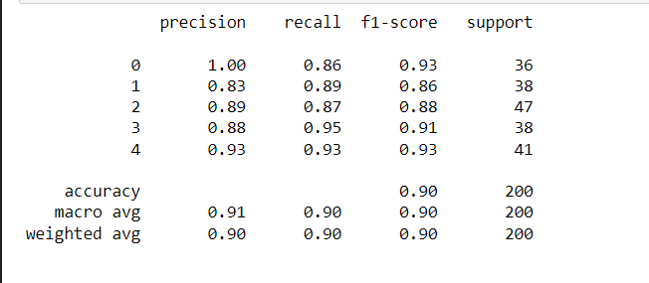

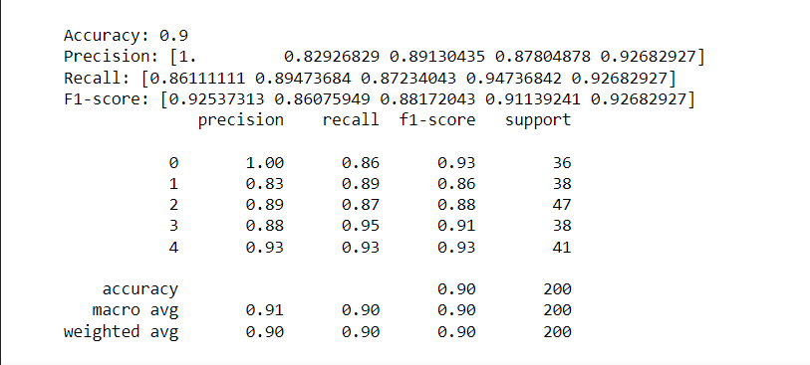

Overview:  
The classification model achieved an accuracy of 90%, indicating strong overall performance. While precision, recall, and F1-scores were relatively balanced across classes, there may still be room for improvement through strategies like addressing class imbalance and fine-tuning hyperparameters. Exploring alternative algorithms or model architectures could also provide insights for enhancing performance further. Additionally, analyzing misclassified instances and incorporating domain knowledge may offer valuable insights for refining the model's predictions.